**Use of Procedures in MIT App Inventor**

◼**Procedures**

**Procedures. Defined on Google as (When in doubt, ask Google):**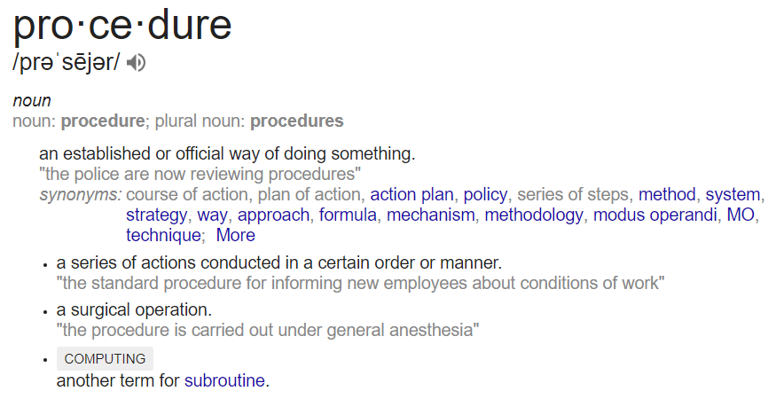

**With the definition of the procedure, Google states it is another word for “subroutine”, which means “a set of instructions to perform a frequently used operation within a program."**

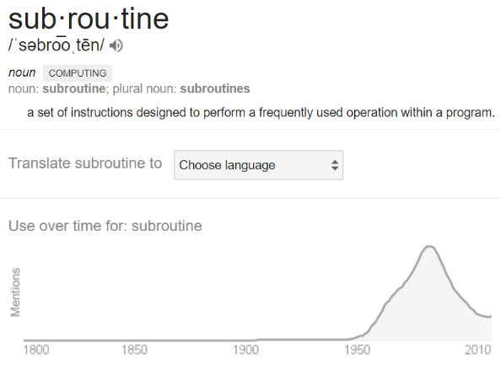Moreover, we can confirm this by the timeline which this word is used in, starting from when the concept of computers and coding was founded back in the 1900s. The concept of procedures has developed throughout the history of programming as more languages are created, and more options added. However, the main purpose of a procedure in Computer Science can be understood as “a set of instruction that is created to more efficiently demonstrate another set of instriuctions that is repeatedly used through out the program.” However, unlike loops, this set of instructions can have a specific input each time it is used in the program. Additionally, procedures are fit with the ability to output needed information such as a result to a set of calculations. Procedures are a great way to avoid repeating code within a large program, or even to organize the code for others to understand when reading it. On a technical stand point, everything from a print function to any code that is not binary is counted as a procedure or function, since it is capable of doing things for you that was not inherited in to the original system and has to be broken down in to simpler steps for the computer to comlete.

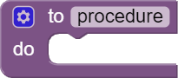**Common Procedure (No Output)**

Found under the procedure subsection within the Build-In functions. One of the most common uses of procedures is just to simplify the repeated code or to have the same code for several occasions. This can be done from a common procedure, which includes no outputs, but can include inputs if the user wishes to have the procedure process a certain value without returning it or to have the GUI (Graphic User Interface) react according to the given value or string. Some examples of this could be a phone generating random numbers when you shake it but also doing the same when it is pressed, or any of it is other sensors are triggered. This is useful in situations where the code is repeated or where the main code is unchanged, but the values may change through out it is other occurrences.

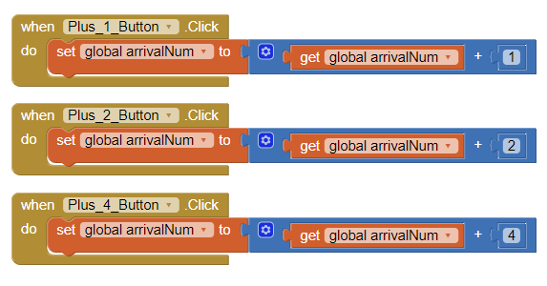**Procedures with Inputs**

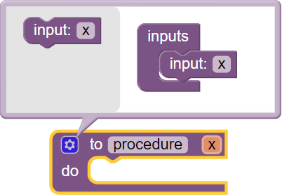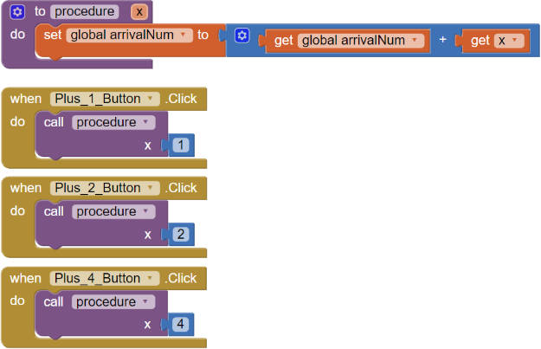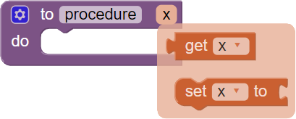Although procedures are useful by themselves, programmers have learned that usually we will need input or there could be a value change throughout the repeated code. This is where the input of a function comes to use; it allows the user to input value when the repeated code has different values but identical main structure. By clicking the gear icon on the created procedure, you will be greeted with more options with the number of inputs you would like in this procedure. The amount of input can be added by draging it in to the inputs block beside it, and then you can assign a custom name to each input. The name will then be used through out the procedure as a local variable that can be changed and manipulated if you wish. This value can then be obtained to be used throughout the program. By hovering the mouse pointer over the variable name will reveals a drop down menu with blocks to obtain the input value and to manipulate it. This value can be used inorder to input the specified value into the repeated code which will take place inside the function. The value can then be imputted through draging the value block to the called procdure’s input.

*Clicking the gear button reveals the inputs to the procedure and allows more to be added.

*Final simplified form which all the buttons calls a procedure with different inputs.

*Hovering the pointer over the name of the input would enable the use of the local variable

*Repeated code with different sets of values that makes the use a procedure with inputs useful.

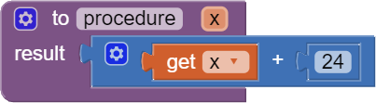**Procedures with Outputs**

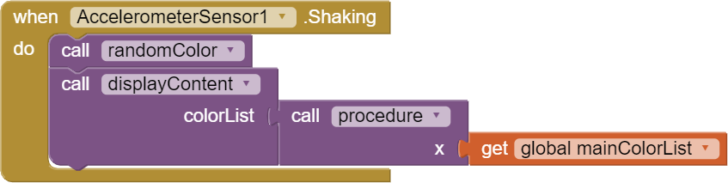Like a variable, output procedures output a certain value or string, which can be used normally fed into another block. Calculations can be done in the procedure by using math blocks, and the input can also be manipulated within the procedure. You may also use the procedure as a constant value such as a number just by outputing a value from it. This block may also have inputs which can be added by the same method as a normal procedure.

**Pratice Questions:**

1. **(EASY) Number Counter**

Make an application with three buttons and one centered label. Each button is responsible for either adding or subtracting a unique amount from the main number. The main number is then to be displayed on the screen inplace of Index #1. *Note: Input Procedure Required

1. **(MEDIUM) Color Randomizer**

Make an application with three indexes at the top, a canvas in the middle, and two buttons at the bottom. The three index will each repersent a part of the RGB values, red at the top, green in the middle, and blue last. The canvas is then to be colored accordingly to the value of the RGB code.

**Challenge Question:**

1. **Simple Calculator**

Using procedures, make a working calculator with the buttons to plus, subtract, multiply, and divide, along with two sliders that will control the two numbers the application handles. Then have a enter button along with a label displaying the answer, and a lable displaying the equation along with the two numbers.